Linear Sleeve Labeling Machine Specification Sheet ZRT-170B

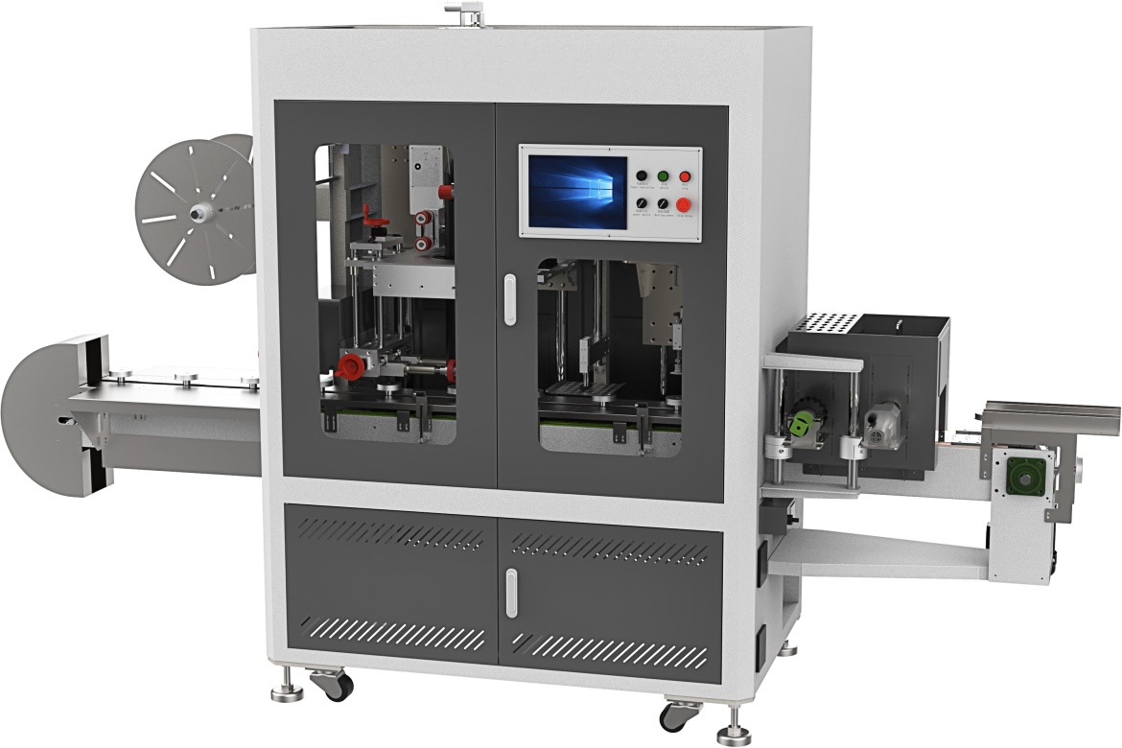
Basic Use：
Mainly used for shrink film and paper card packaging of various adhesive tapes. It supports sleeving and shrink wrapping for single or multiple cylindrical adhesive tape products.
Equipment Advantages：
This machine is specially designed for film sleeving and shrink packaging of cylindrical adhesive tape products. When matched with a constant-temperature PVC shrink tunnel, it delivers complete and excellent shrink wrapping results. Featuring wide application range, high economic benefit and easy operation, the machine is compatible with PVC film as packaging material.Compared with manual packaging, it greatly reduces packaging costs. Products wrapped by this machine feature neat and attractive appearance, tight package without loosening, guaranteed product quality and suitability for long-distance transportation.
Main Technical Parameters:
Power Supply | AC380/AC220 50～60HZ
Total Power | 12KW
Hot Air Gun Power | 8.8KW(4 pcs)
Packable Diameter Range | 50-130MM
Packaging Speed | 50PCS
Conveyor Height | 780+50MM(Adjustable)
Working Air Pressure | 5～7kgf/cm²
Overall Machine Dimension (L*W*H) | 3500*900*2000MM
Net Machine Weight | 1500kg
Configuration Parameters:
Model | ZRT-170B
touch screen | MCGS
Film feed servo | HCFA
film feeder | HCFA
Film cutting servo | HCFA
Film cutting drive | HCFA
Absorption servo | HCFA
Suction drive | HCFA
Reducer | SMT
PLC Controller | HCFA
Air Switch | CHINT
AC Contactor | Schneider
Switching Mode Power Supply | MINGWEI
electric machinery | MAILI
Photoelectric switch | BOJKE
Solid-state relay | YANGMING
relay | IDEC
Temperature Controller | Taie
frequency converter | cost
Button switch | Schneider
Cylinder | Star
filter | STNC
Solenoid valve | STNC
Vacuum Solenoid Valve | ASiCKO
Magnetic switch | AirTAC
vacuum generator | ASiCKO
Bearing | NSK
frame | Imported powder spraying

